* PhD Annual Review System

Iteration 0

**Neha Joshi** - Product Owner

**Shwetima Sakshi** - Scrum Master

**Prachi Surbhi** - Developer

**Harshvardhan Surolia -** Developer

**Shashank Jagtap -** Developer

**Will Harper –** Developer

**John Keyser** - Client

**Recurring Client Meeting Time**

- Every Wednesday at 2 pm

## Summary

The client wants us to create an annual PhD review system, a web application that will streamline the annual PhD review process. The system will have three types of users: PhD students, faculty/reviewing committee members, and administrators. PhD students will be able to use the system to upload their CV, annual review progress report, and upload a form which will ask them about statement of prior work and future plans, and other relevant materials. They will also be able to select the milestones they have passed, indicate if they had an improvement plan last year, and declare their financial support and publications. Faculty reviewing committee members will be able to view students' CVs, progress reports, and other materials. They will also be able to submit ratings and review comments and nominate students for rewards. Administrators will be able to view all the above information, as well as generate reports on student progress and review outcomes. The client has told us that using the current review system is cumbersome as all the info is not available in one view and the faculty need to switch between views. The client also asked us to come up with a view for the administrator which will have all the info and status of each responsible party, this view will help us the admin to see if the students have submitted all the required documents, what evaluation they have received from each committee member and what are their final evaluation score.

The annual PhD review system will provide several benefits for all stakeholders. For students, it will make it easier to track their progress and ensure that they are on track to complete their degree on time. For faculty, it will streamline the review process and provide them with a centralized platform to store and review student materials. All the committee members will be able to see all the student document in a single view which is one of the requirements of the client. For administrators, it will provide valuable insights into student progress and help them to identify students who may need additional support. Admin can easily generate reports to identify the students who haven’t received a satisfactory evaluation outcome. Overall, the annual PhD review system will be a valuable tool for helping PhD students to succeed and for ensuring the quality of PhD programs.

## User Stories:

**User Story 1: Login main system**

As a user

So that I can then login into the interface

I want to create an account on the Ph.D. Annual Review System with my username, password, and email.

**User Story 2: Student Login**

As a student user with an account on the Ph.D. Annual Review System

So that I can create/update my profile

I want to use my username and password to login to my account from the login page

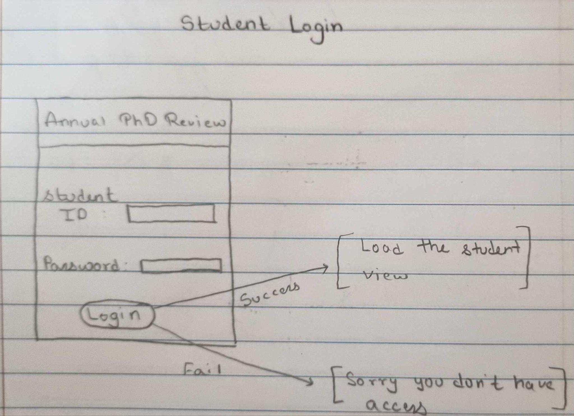

**User Story 3: Document submission**

As a PhD student

So that I can submit documents to my faculty committee

I want to be able to submit documents like a report and resume.

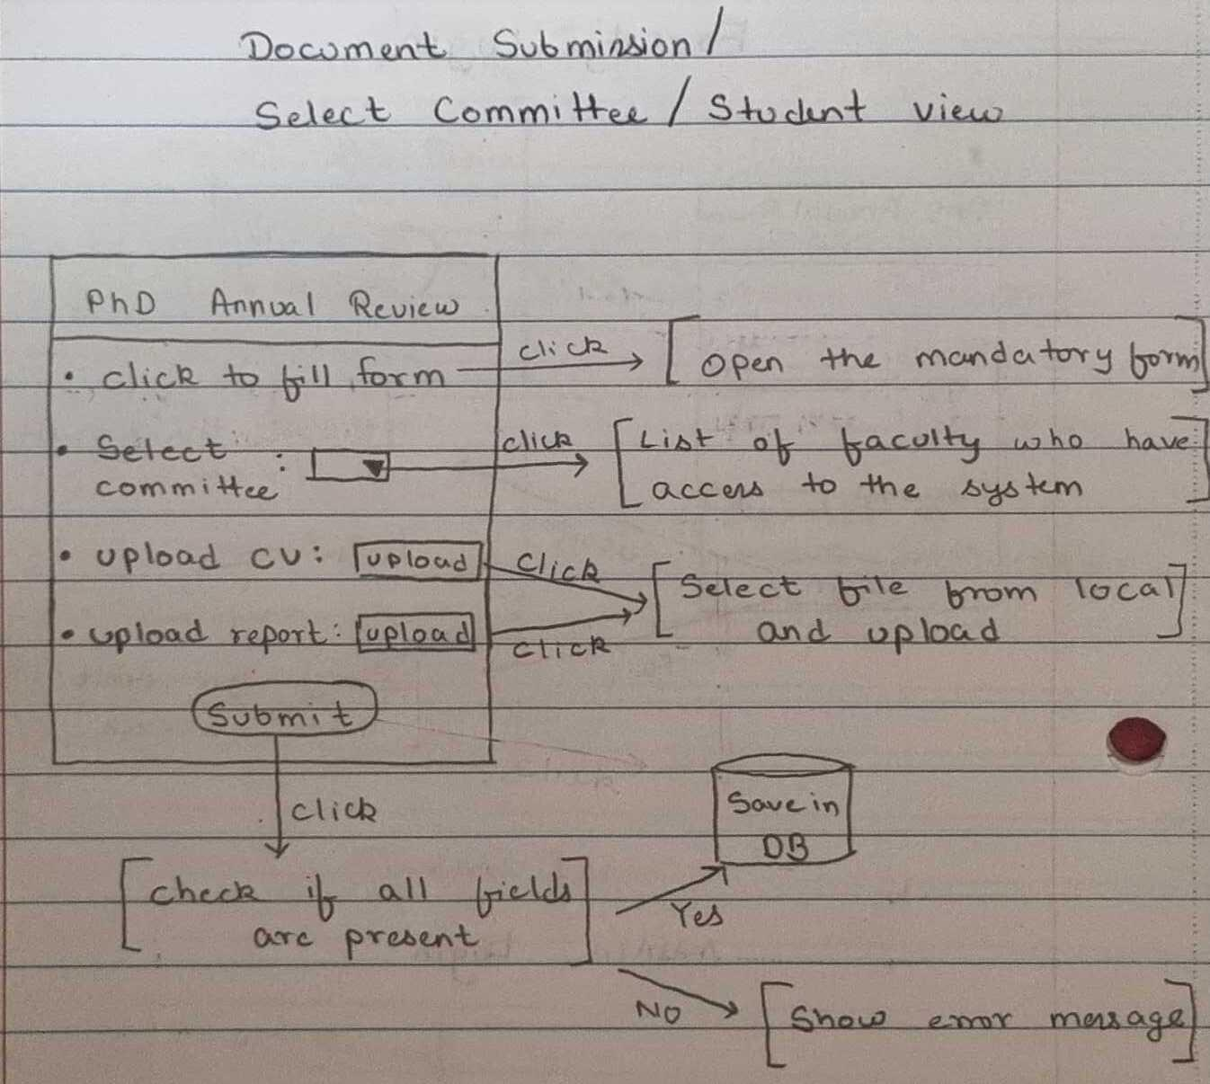

**User Story 4: Faculty Login**

As a student user with an account on the Ph.D. Annual Review System

So that I can create/update my profile

I want to use my username and password to login to my account from the login page

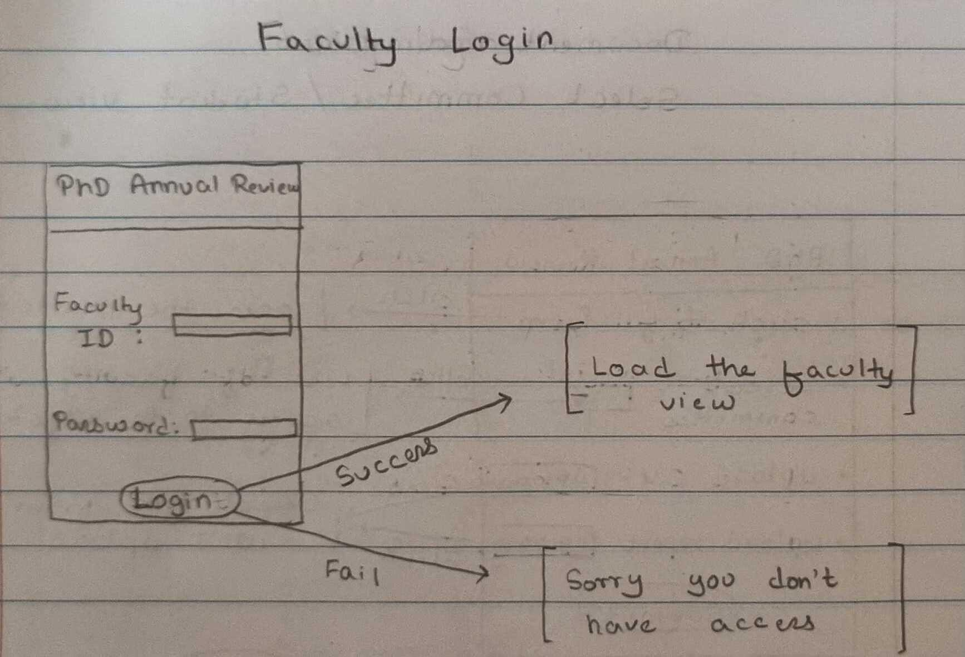

**User Story 5: Faculty committee submitting ratings, review comments and nominations.**

As a faculty member

So that I can review PhD candidates’ documents

I want to leave comments, evaluate and nominate them for rewards.

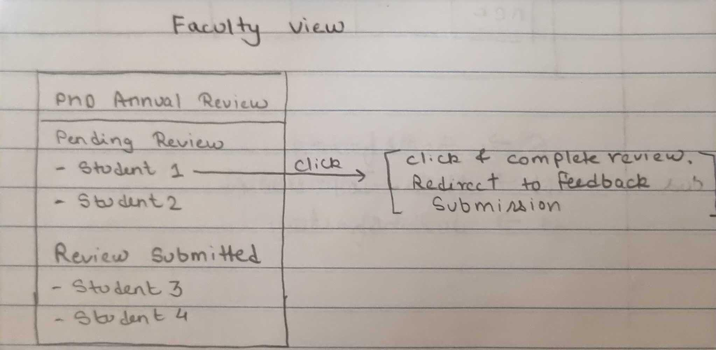

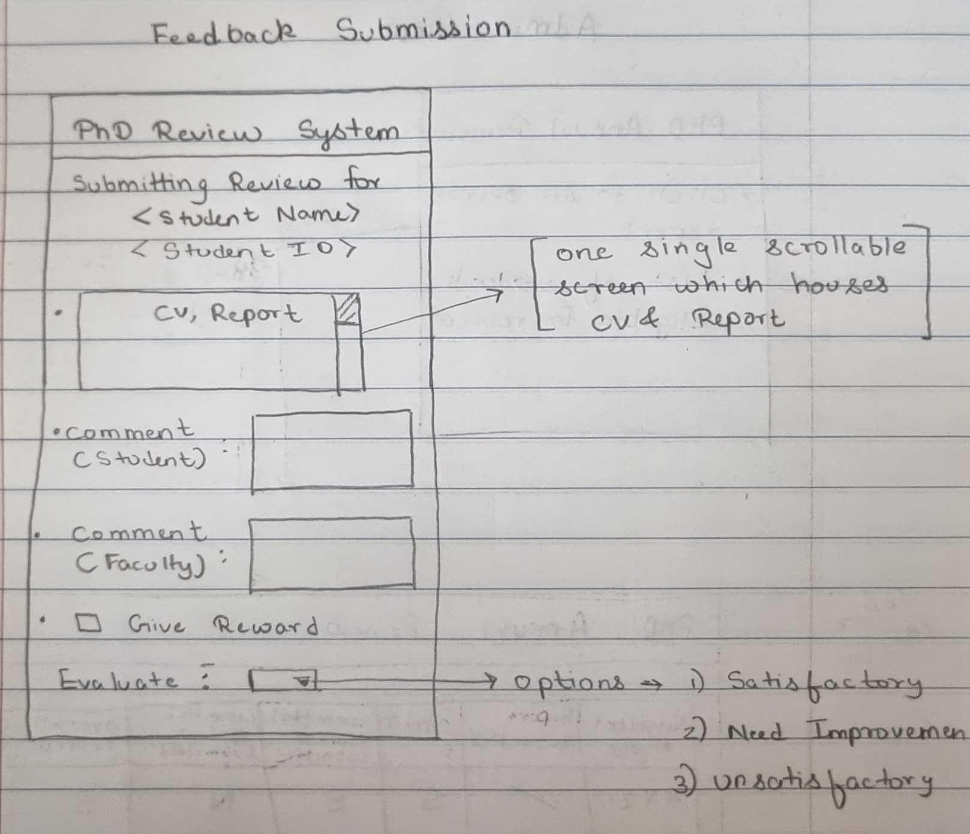

**User Story 6: Admin reviewing student’s profile and evaluation.**

As the admin

So that I can view the students’ profiles and the evaluations submitted by all the committee members

I want to log in to the system to view students’ profiles, evaluations and nominations in the form of a single PDF report.

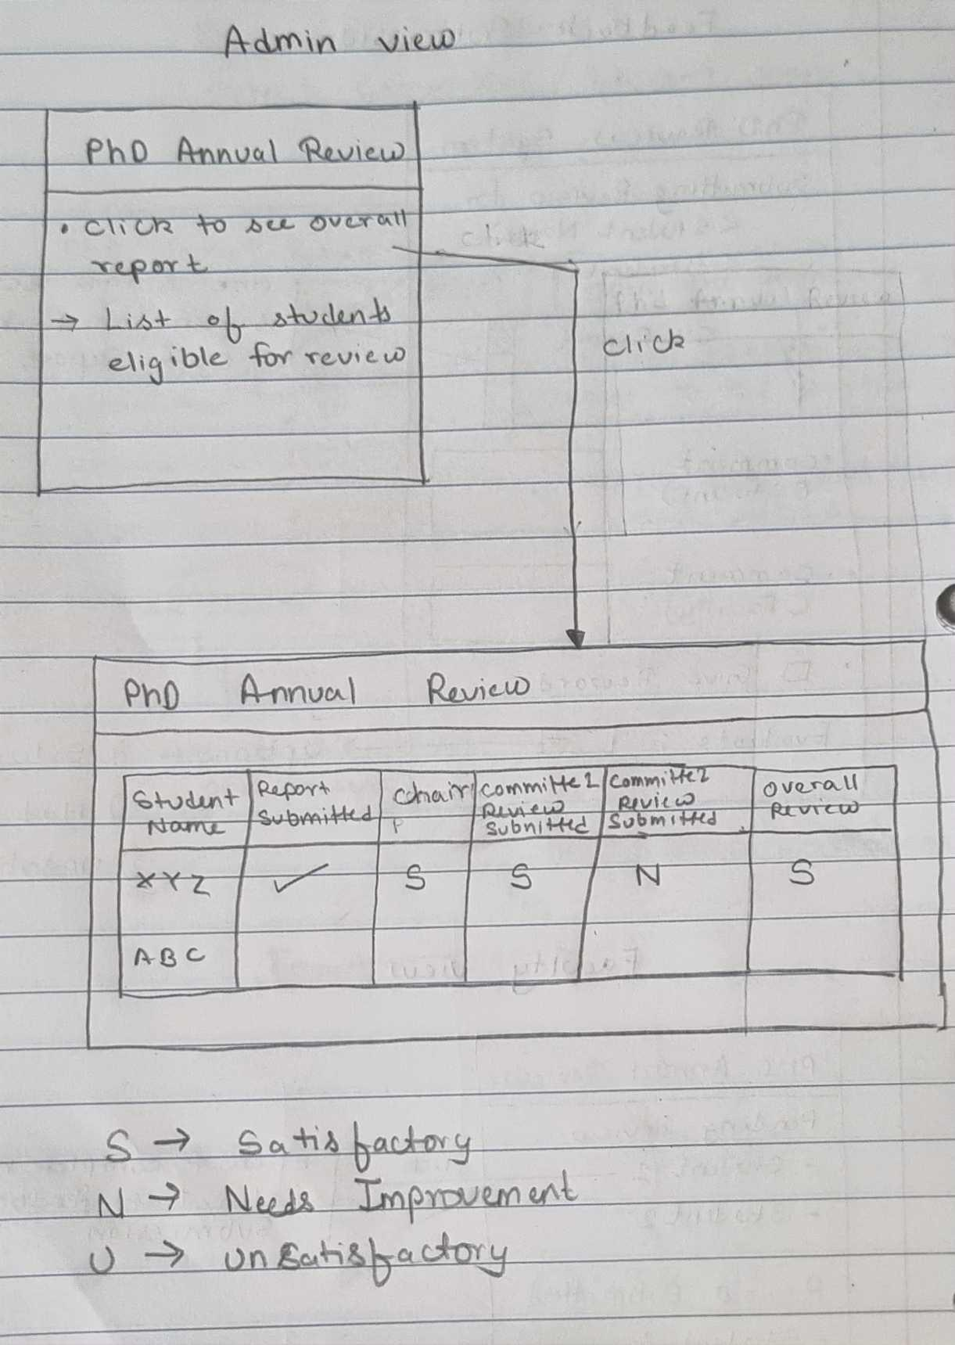

## Links

**Deployed App** -

<https://phd-review-app-0416787b021c.herokuapp.com/>

**GitHub Repo** -

<https://github.com/PhD-Annual-Review-System/PhD-Annual-Review-System>

**Project Management page** -

<https://github.com/orgs/PhD-Annual-Review-System/projects/2/views/1?layout=board>

**Slack channel -**

<https://join.slack.com/t/phdannualreviewsystem/shared_invite/zt-238v24zn7-M5aki4jjOUG3Hb0Kn5vqjQ>

**Storyboard -**

https://github.com/PhD-Annual-Review-System/PhD-Annual-Review-System/issues